**Mobile Website Design:**

Team Eduris decided to preview some of the important features which will guide the user to register. Below are the images of the mobile website,

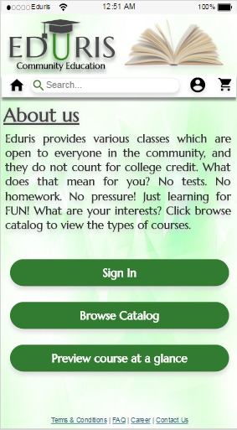

**Image 1: Homepage**

Image 1 is the homepage of “Eduris Community education”. It has the basic features containing logo, home icon, search bar, profile icon, cart icon. It also gives a brief description of the website. Below the description of the website are the three buttons which helps the user to sign in, browse catalogue (types of streams and courses), and preview course a glance option. Our main feature is to help the user to register for the course.



**Image 2: Catalog**

When the user taps on the browse catalog button, the user is redirected to the catalog page, where there are multiple streams of courses available. The user then taps on the desired stream and then a drop down is seen for that particular stream. For example in the above image we see that “Culinary” is a stream and when tapped on that stream, a drop down of available courses are displayed. Then the user can select the desired course.

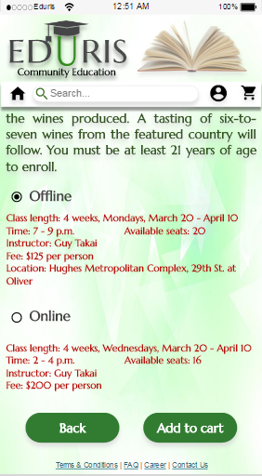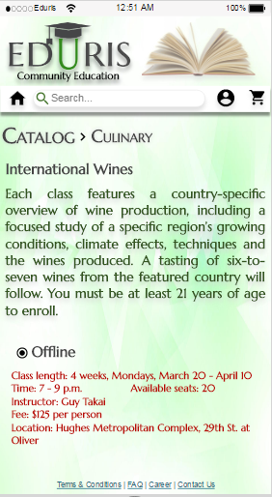

**Image 3: Course details**

After the user taps on the desired course the user can, the details of the course are shown along with the types of classes available. It also displays the number of seats available. The user can select an online or an offline class. After selectin the desired option the user should tap on the “Add to cart” option. To complete the registration the user needs to login and complete the payment to register.